Test Case: runTestMultipleTimes
Step 1 - Enter username and password and click to button Enter : Credentials Entered
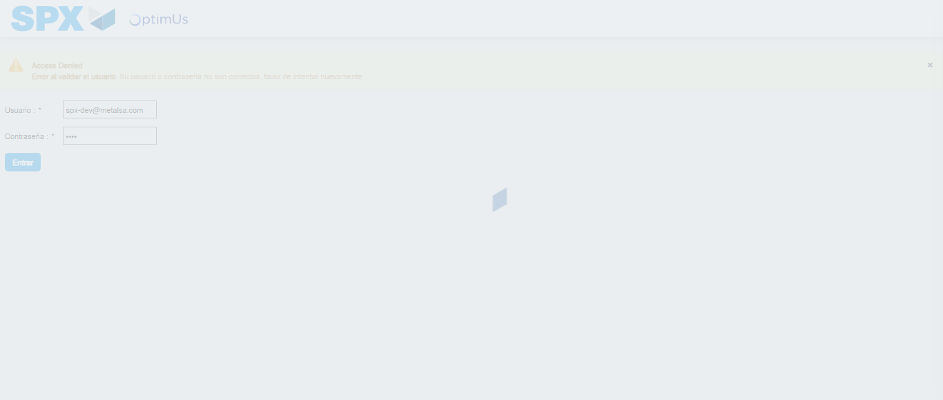Image file-name: QC_Testing-runTestMultipleTimes-nov. 25 2025, 03 23 41 p. m.

Step 2 - Select to UEN and Access to Spot Buy Requisitions : UEN Correctly selected and Correct access
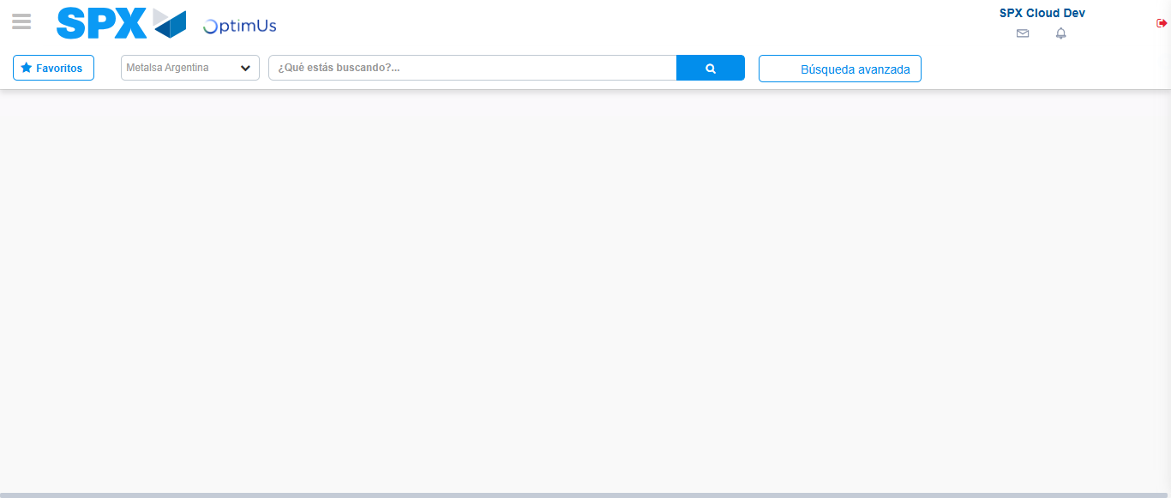Image file-name: QC_Testing-runTestMultipleTimes-nov. 25 2025, 03 23 44 p. m.

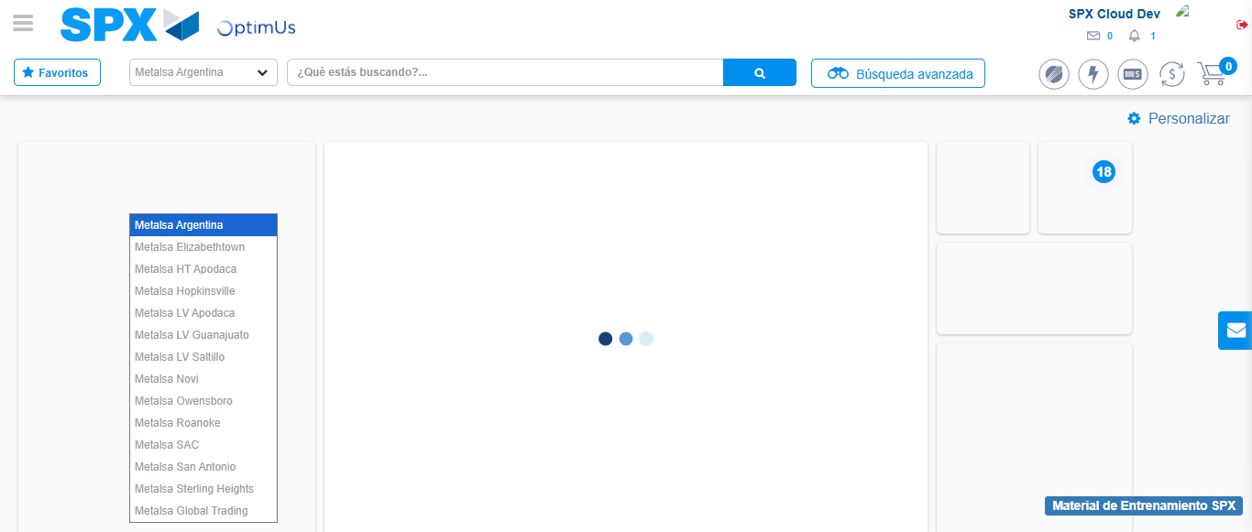Image file-name: QC_Testing-runTestMultipleTimes-nov. 25 2025, 03 23 45 p. m.

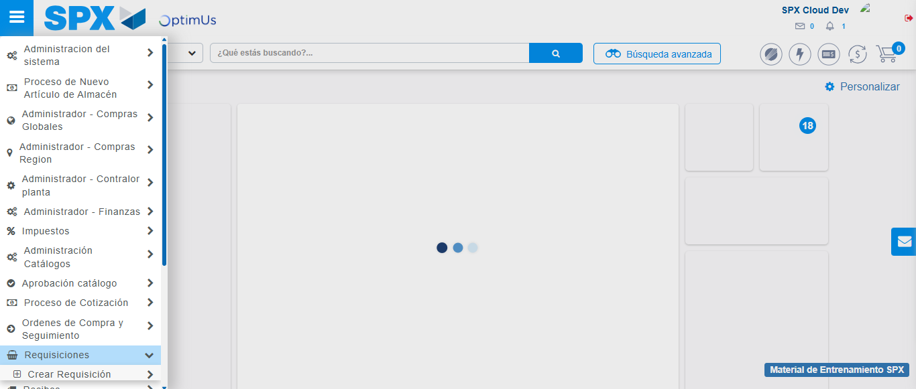Image file-name: QC_Testing-runTestMultipleTimes-nov. 25 2025, 03 23 46 p. m.

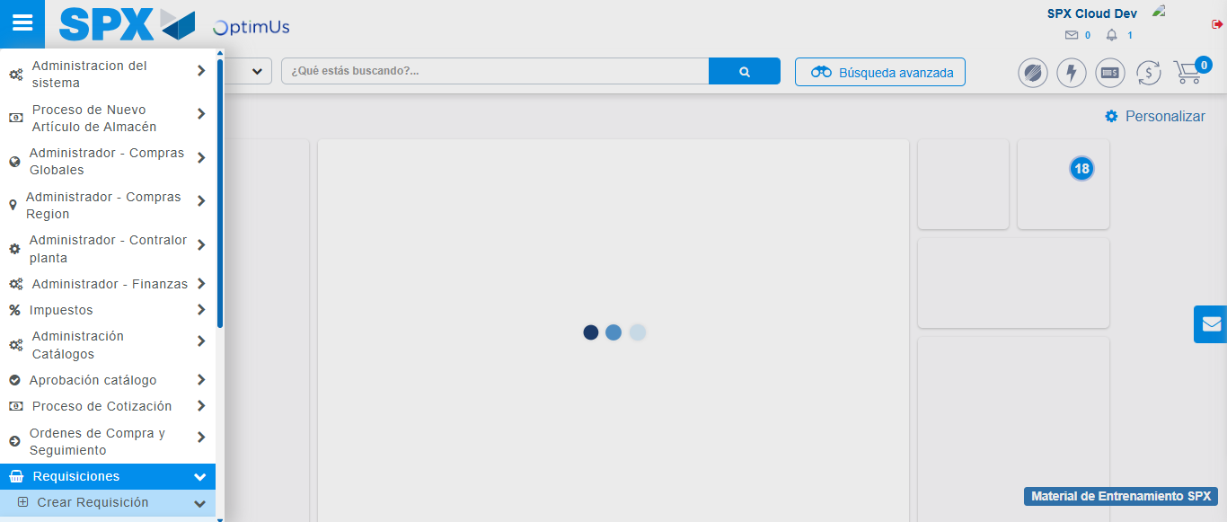Image file-name: QC_Testing-runTestMultipleTimes-nov. 25 2025, 03 23 47 p. m.

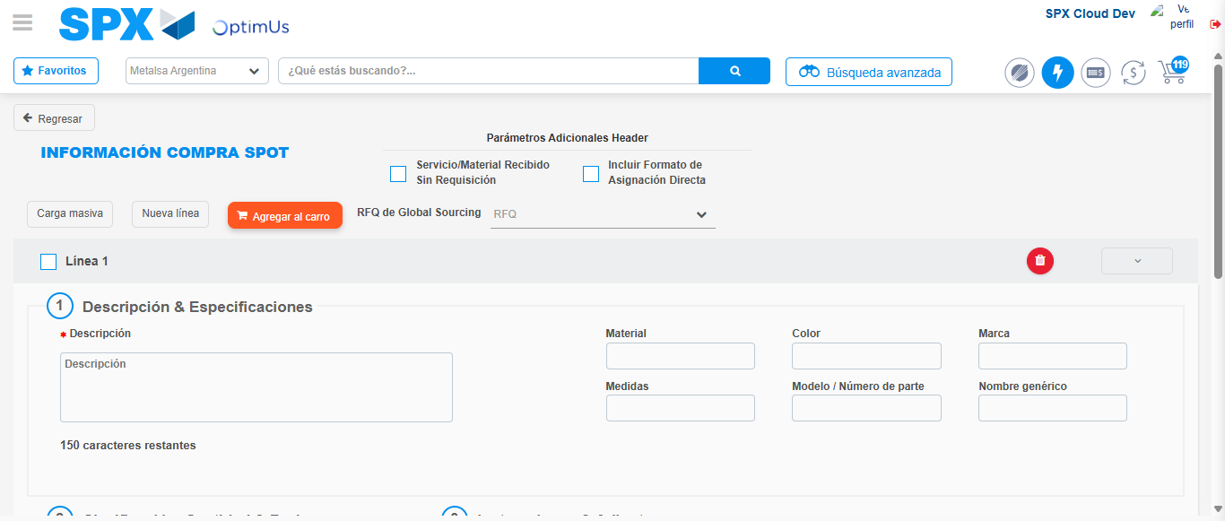Image file-name: QC_Testing-runTestMultipleTimes-nov. 25 2025, 03 23 58 p. m.

Step 3 - Data Capture Spot Buy Requisition : Data captured correctly
Image file-name: QC_Testing-runTestMultipleTimes-nov. 25 2025, 03 23 58 p. m.

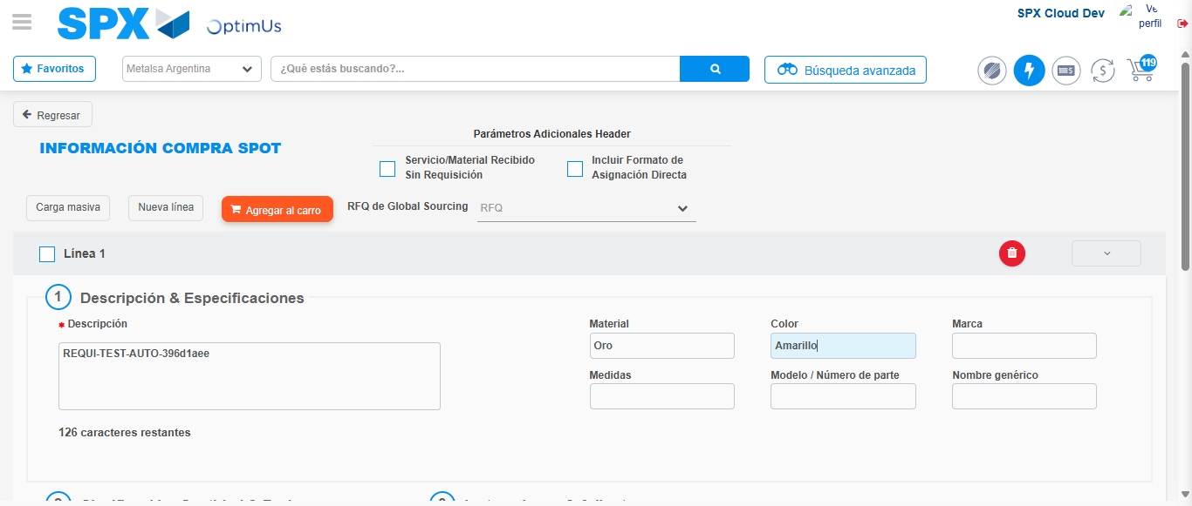Image file-name: QC_Testing-runTestMultipleTimes-nov. 25 2025, 03 23 59 p. m.

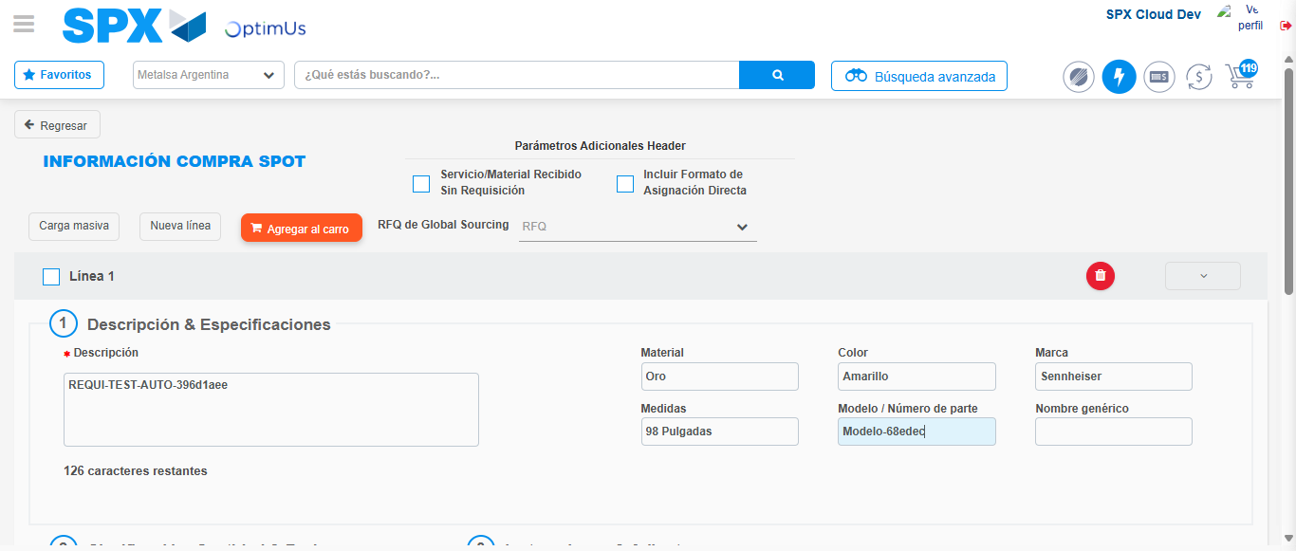Image file-name: QC_Testing-runTestMultipleTimes-nov. 25 2025, 03 24 00 p. m.

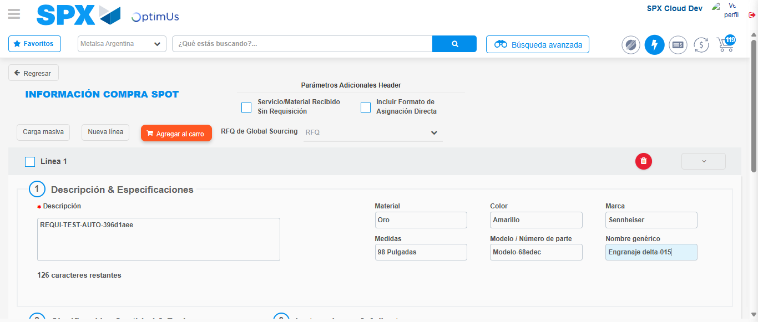Image file-name: QC_Testing-runTestMultipleTimes-nov. 25 2025, 03 24 01 p. m.

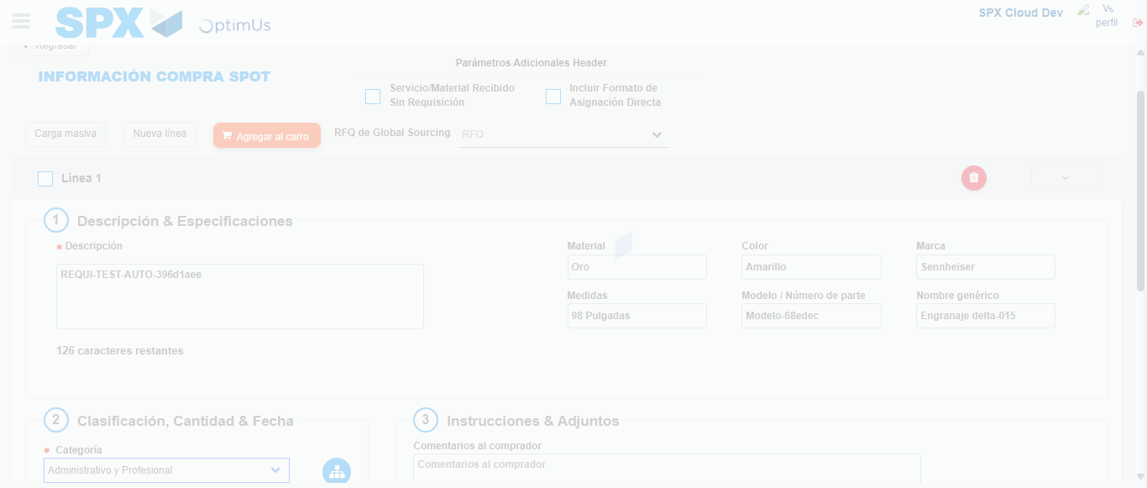Image file-name: QC_Testing-runTestMultipleTimes-nov. 25 2025, 03 24 02 p. m.

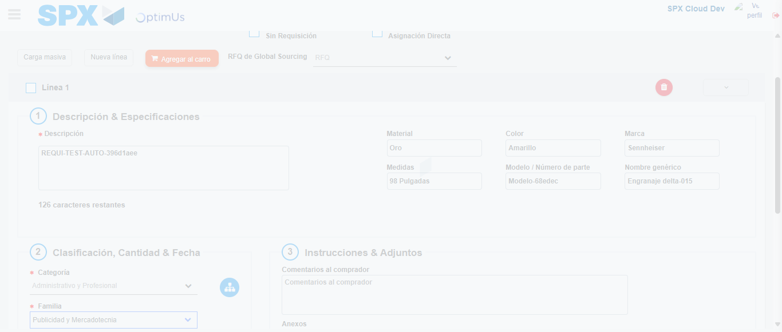Image file-name: QC_Testing-runTestMultipleTimes-nov. 25 2025, 03 24 03 p. m.

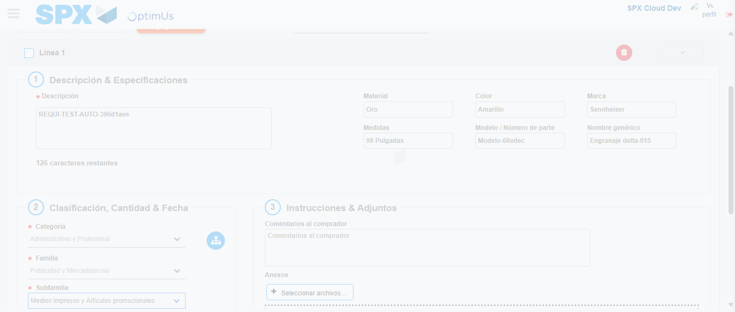Image file-name: QC_Testing-runTestMultipleTimes-nov. 25 2025, 03 24 04 p. m.

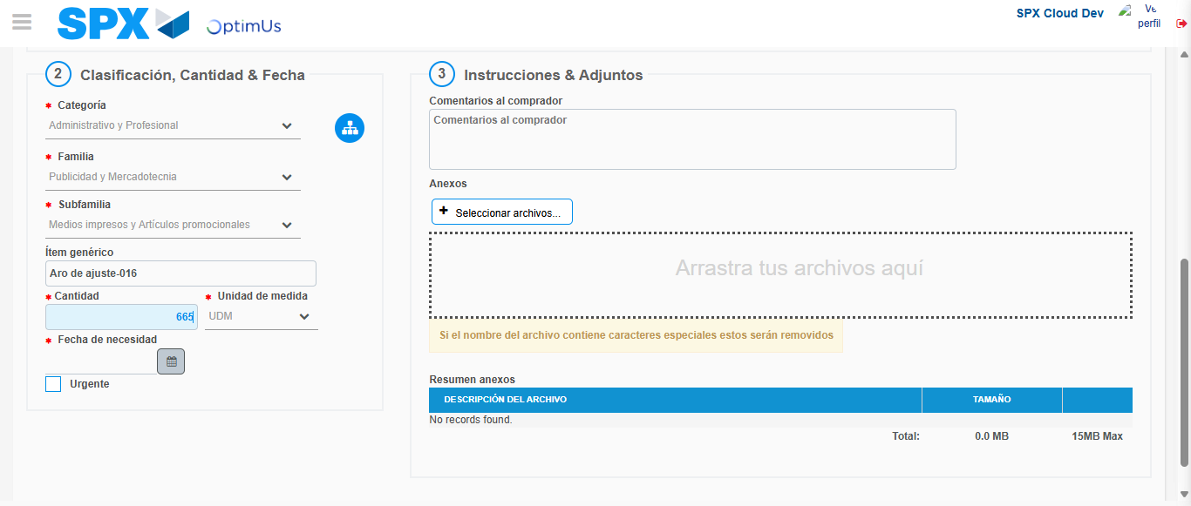Image file-name: QC_Testing-runTestMultipleTimes-nov. 25 2025, 03 24 05 p. m.

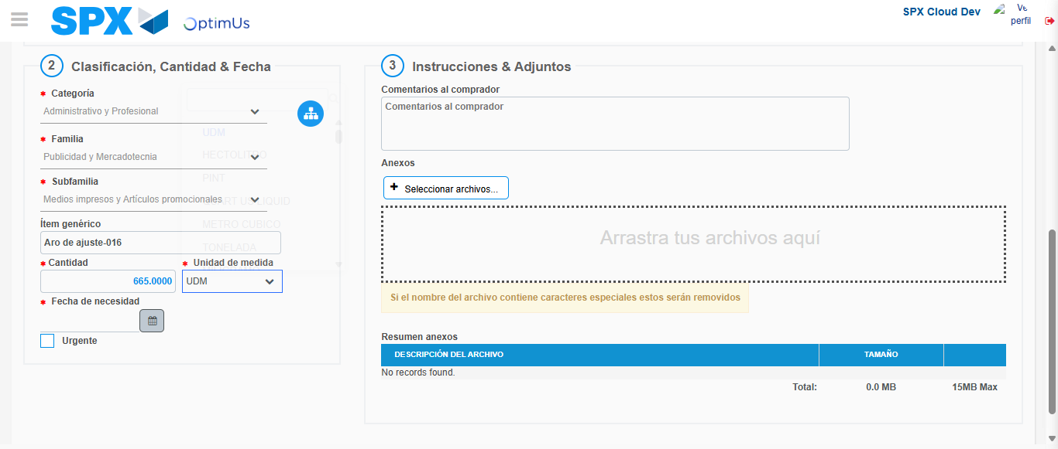Image file-name: QC_Testing-runTestMultipleTimes-nov. 25 2025, 03 24 06 p. m.

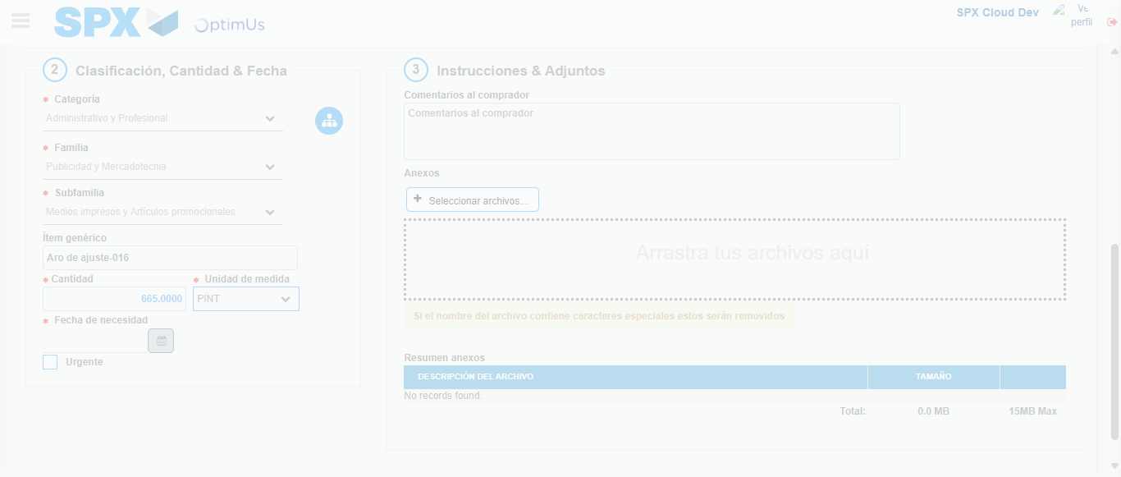Image file-name: QC_Testing-runTestMultipleTimes-nov. 25 2025, 03 24 07 p. m.

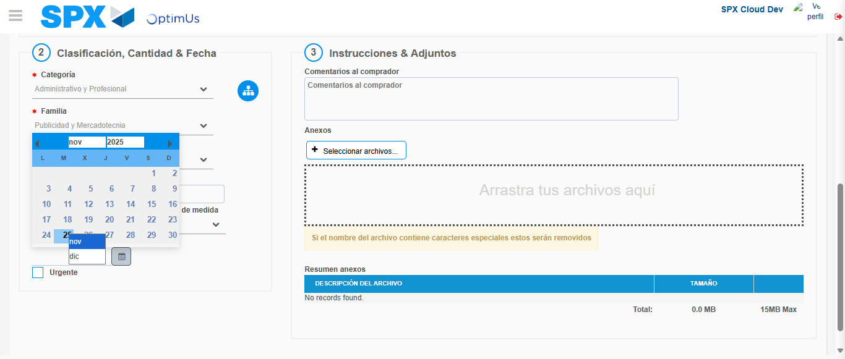Image file-name: QC_Testing-runTestMultipleTimes-nov. 25 2025, 03 24 08 p. m.

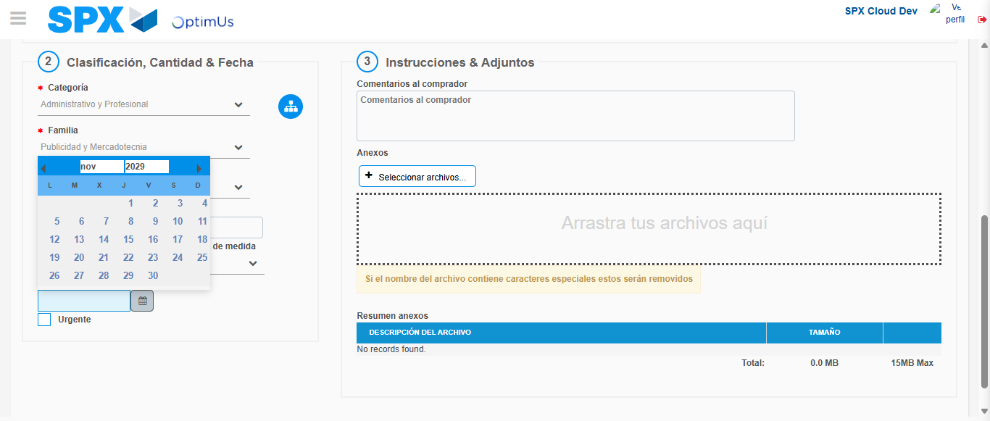Image file-name: QC_Testing-runTestMultipleTimes-nov. 25 2025, 03 24 09 p. m.

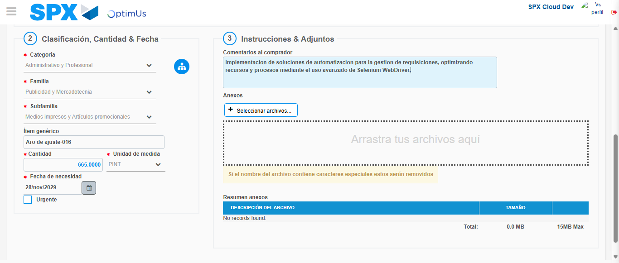Image file-name: QC_Testing-runTestMultipleTimes-nov. 25 2025, 03 24 10 p. m.

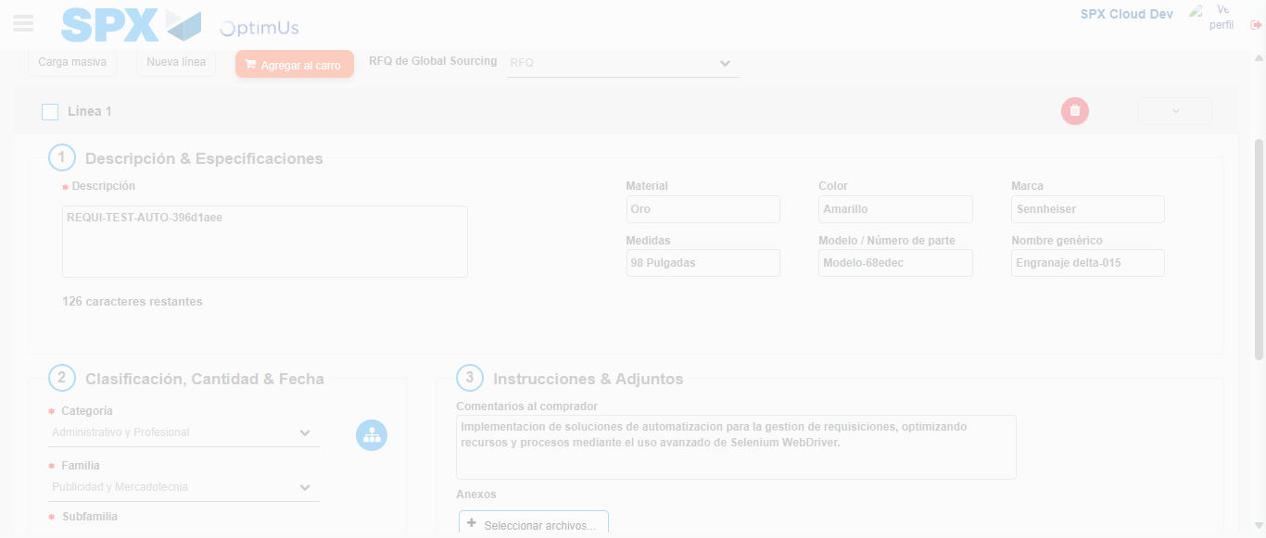Image file-name: QC_Testing-runTestMultipleTimes-nov. 25 2025, 03 24 11 p. m.

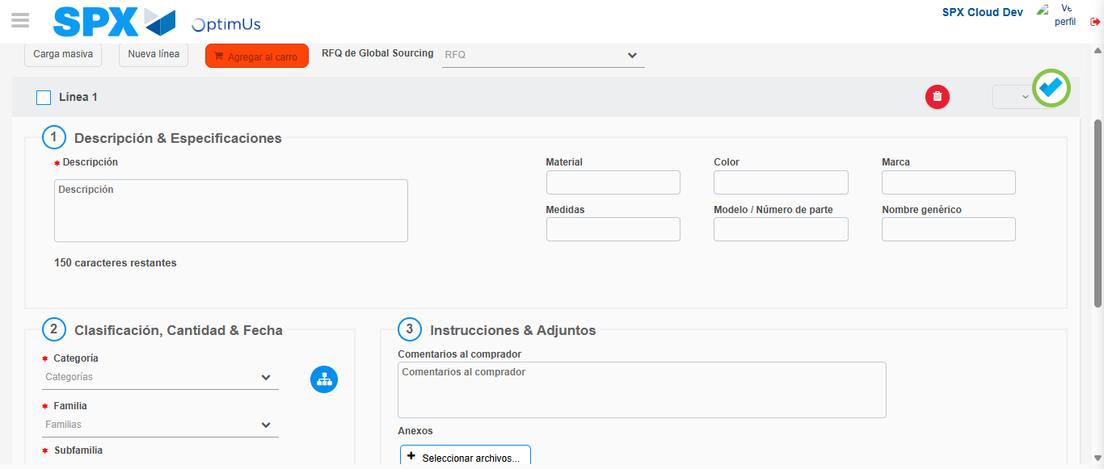Image file-name: QC_Testing-runTestMultipleTimes-nov. 25 2025, 03 24 14 p. m.

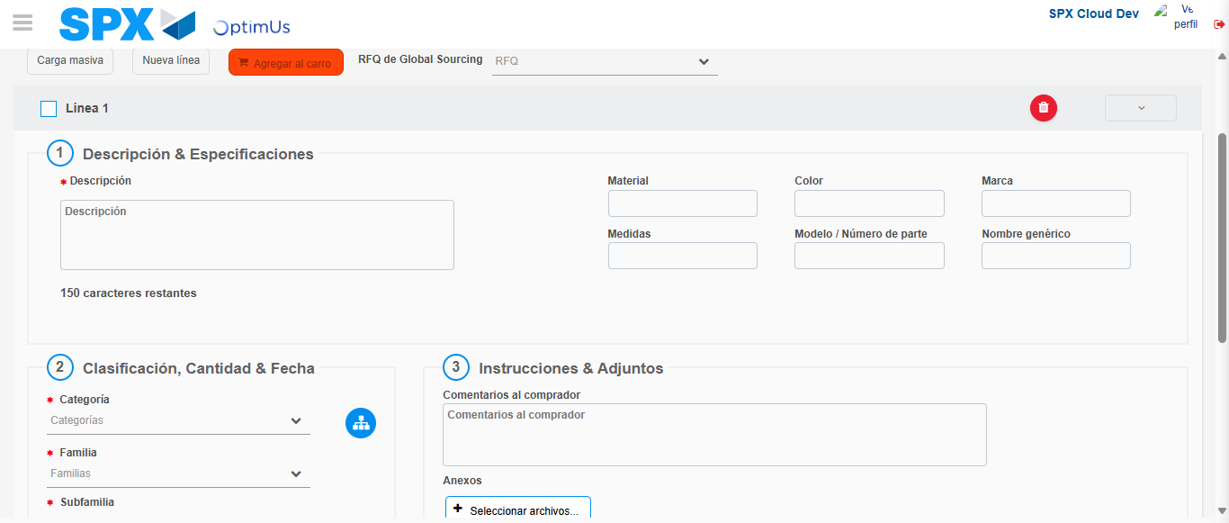Image file-name: QC_Testing-runTestMultipleTimes-nov. 25 2025, 03 24 15 p. m.

Step 4 - Select to Requisition : Requisition Correctly selected
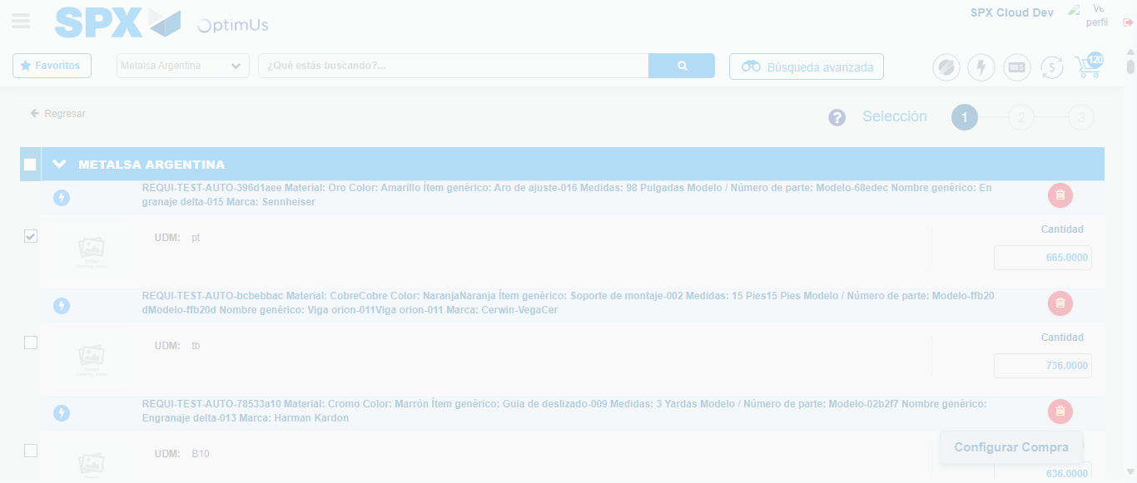Image file-name: QC_Testing-runTestMultipleTimes-nov. 25 2025, 03 24 23 p. m.

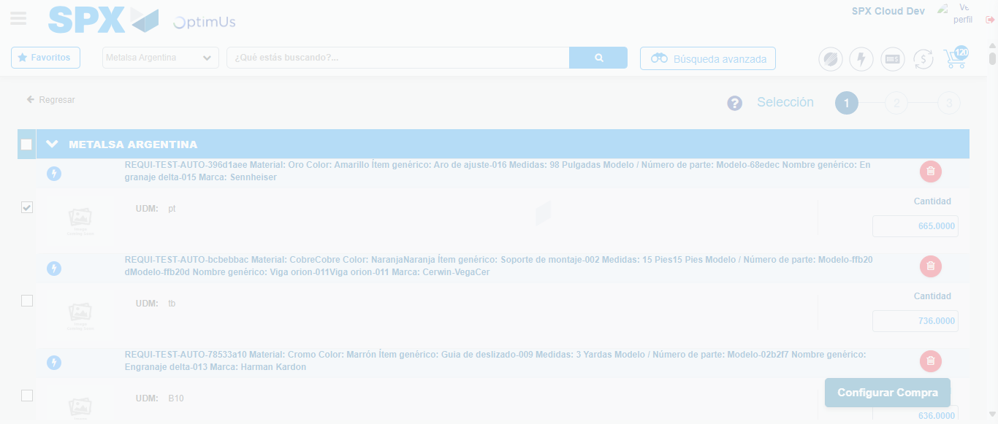Image file-name: QC_Testing-runTestMultipleTimes-nov. 25 2025, 03 24 27 p. m.

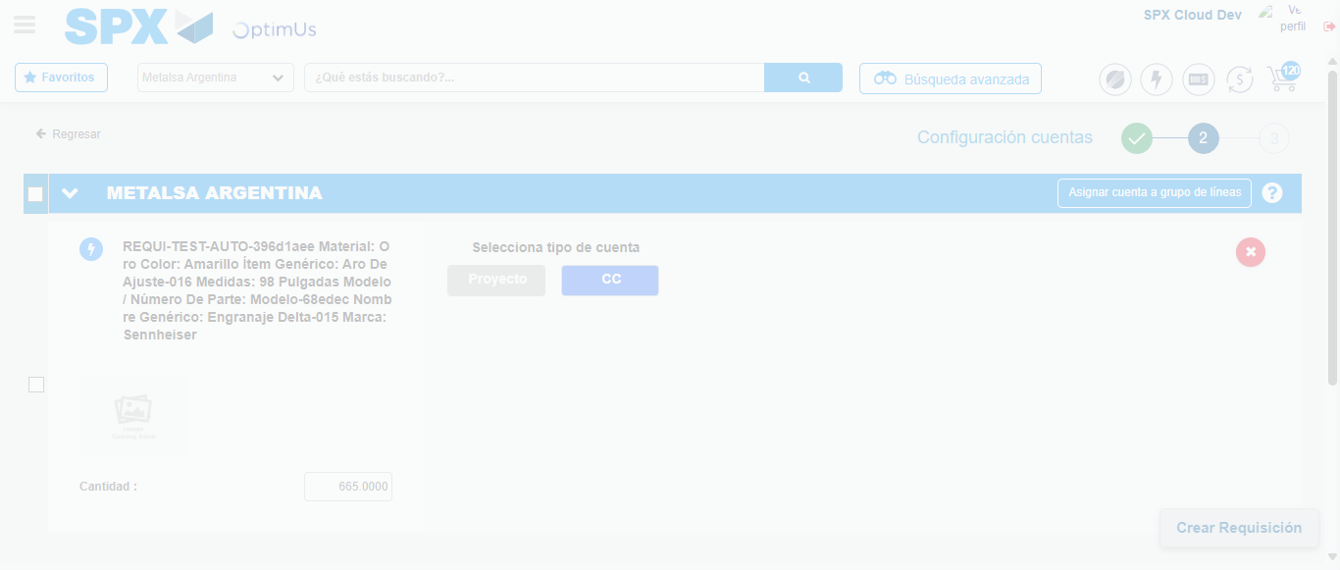Image file-name: QC_Testing-runTestMultipleTimes-nov. 25 2025, 03 24 30 p. m.

Step 5 - Select Type Account For Requisition : Type Account Correctly selected
Image file-name: QC_Testing-runTestMultipleTimes-nov. 25 2025, 03 24 30 p. m.

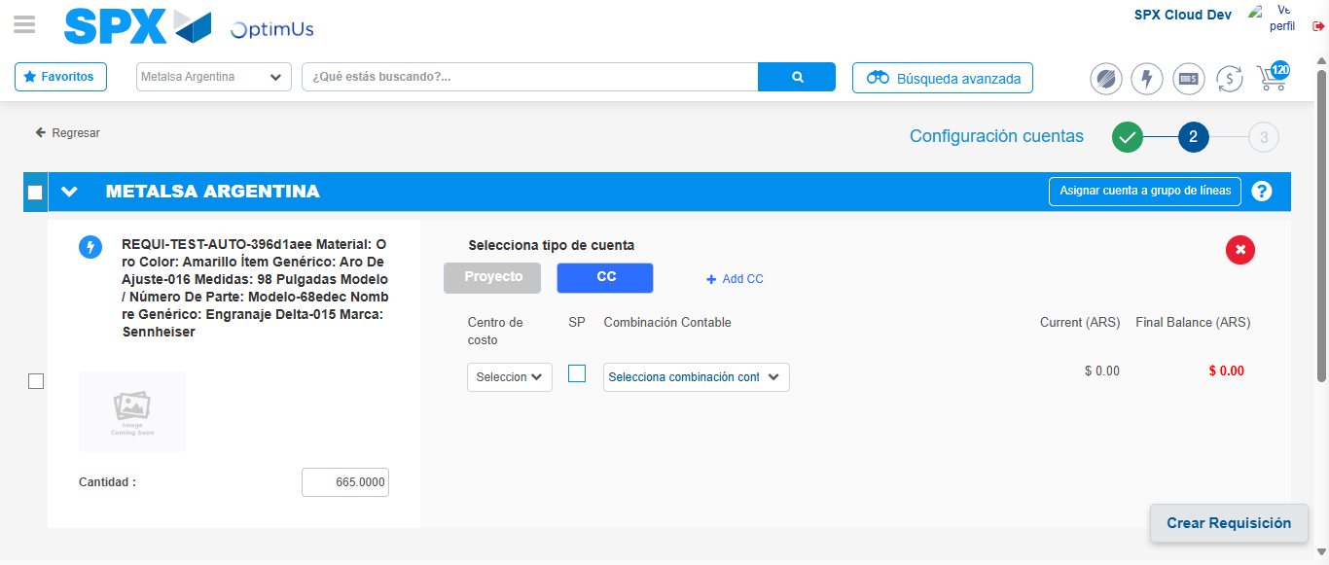Image file-name: QC_Testing-runTestMultipleTimes-nov. 25 2025, 03 24 34 p. m.

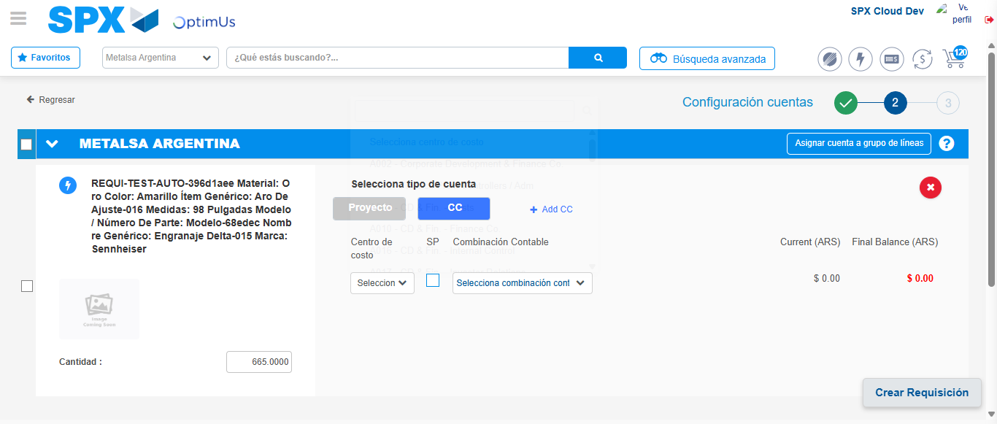Image file-name: QC_Testing-runTestMultipleTimes-nov. 25 2025, 03 24 37 p. m.

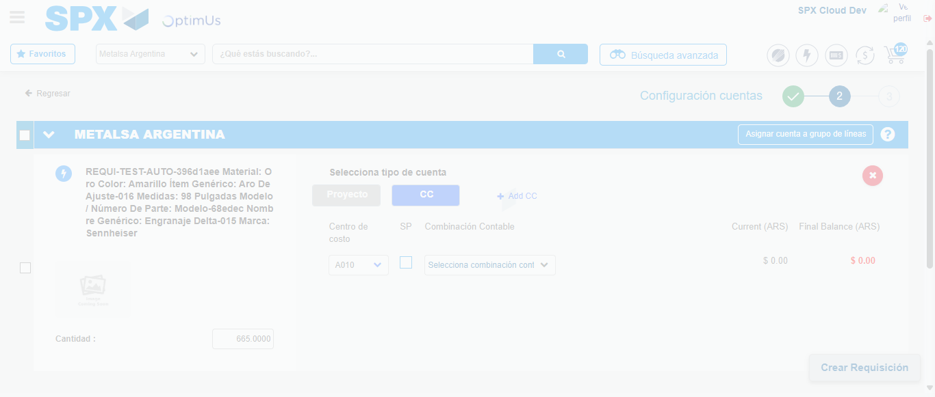Image file-name: QC_Testing-runTestMultipleTimes-nov. 25 2025, 03 24 38 p. m.

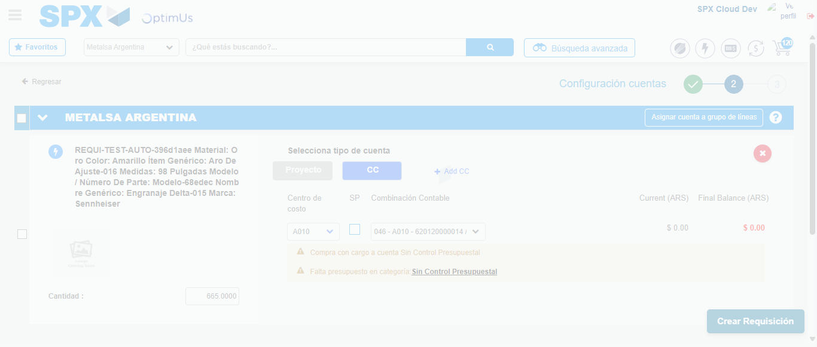Image file-name: QC_Testing-runTestMultipleTimes-nov. 25 2025, 03 24 41 p. m.

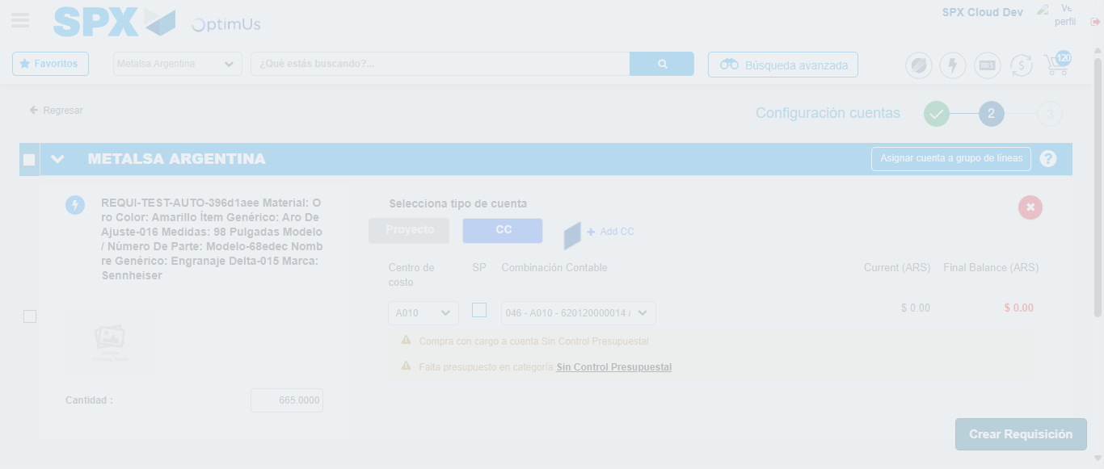Image file-name: QC_Testing-runTestMultipleTimes-nov. 25 2025, 03 24 42 p. m.

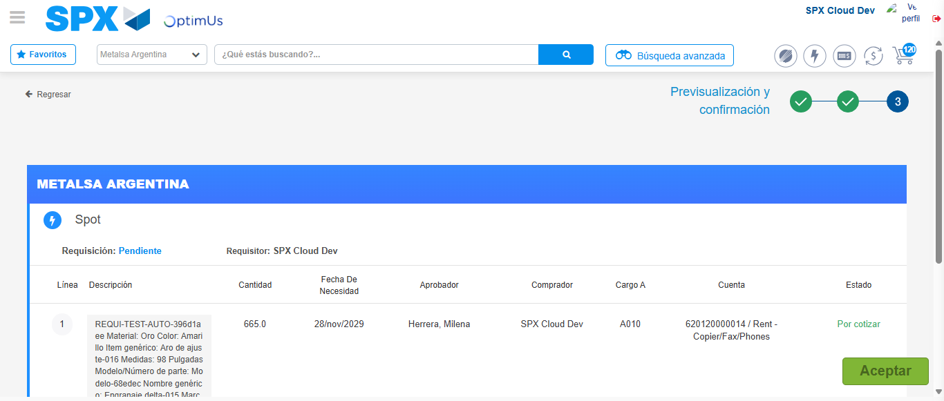Image file-name: QC_Testing-runTestMultipleTimes-nov. 25 2025, 03 24 45 p. m.

Step 6 - Accept to Requisition : Requisition Accepted
Image file-name: QC_Testing-runTestMultipleTimes-nov. 25 2025, 03 24 45 p. m.

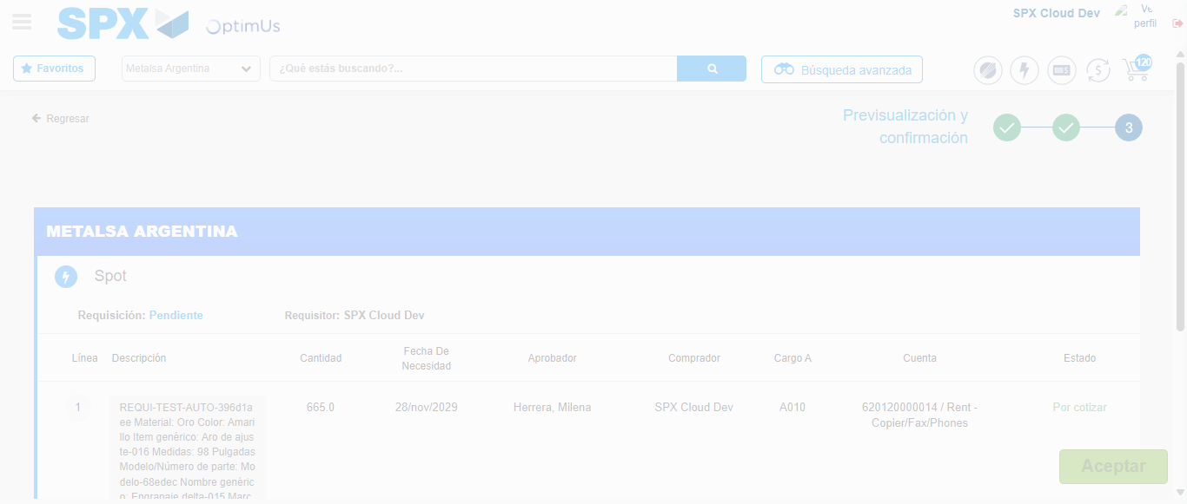Image file-name: QC_Testing-runTestMultipleTimes-nov. 25 2025, 03 24 46 p. m.

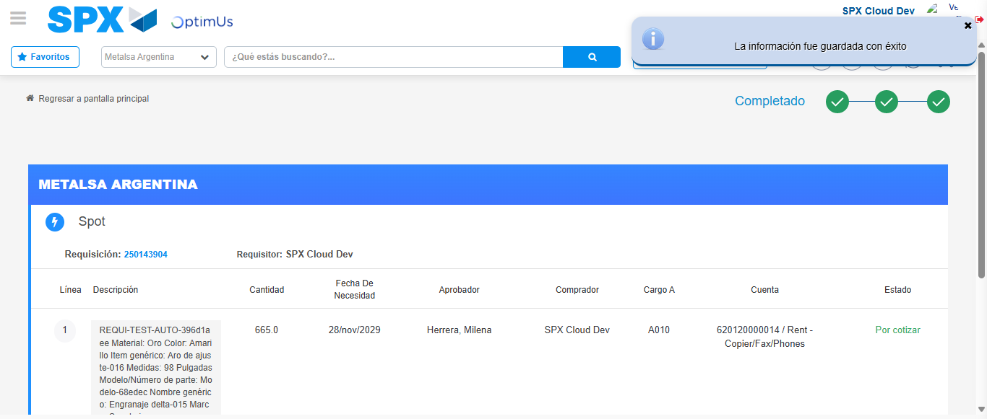Image file-name: QC_Testing-runTestMultipleTimes-nov. 25 2025, 03 24 49 p. m.

